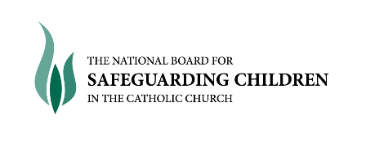
2nd October 2012

Dear Colleague,

As you are aware, in February 2012 we held our first meeting of the National Case Management Reference Group (NCMRG). It was agreed that this initiative would be run on a pilot basis of 12 months, with a review to establish if there was a need to extend the group after the pilot stage.

As part of the review, NBSCCCI have asked Eoin O’Mahony, researcher with the Episcopal Conference to carry out an evaluation and prepare a report on his findings, which will be considered by the Board in January 2013. Eoin has already started work on his evaluation and has attended a NCMRG meeting, met members and has arranged to interview a selection of Dioceses and Religious Congregations who have presented cases to the Group. Given the sensitive nature of the cases presented, Eoin has signed a confidentiality agreement.

The next part of the process is for Eoin to distribute a short confidential questionnaire for completion, seeking the views of all those who have joined the initiative since February, 2012. I appreciate that you are all busy people, but in order to assess the value of the NBSCCCI, I would like your co-operation with completing this questionnaire. I also understand that some of you may not have as yet presented a case to the NCMRG, in this instance only a few of the questions will apply.

The survey questionnaire will be forwarded to you by Eoin no later than October 22nd.

Thank you, in anticipation of your support during this important assessment of the NCMRG.

Yours sincerely,

_______________________
Teresa Devlin
Director of Safeguarding

